FULLSTACK PYTHON

INTERNSHIP REPORT

Submitted to the KG College of Arts and Science in partial fulfillment of the requirements for the degree of B.Sc. Information Technology

Submitted by

NAVEEN .V

(Reg.No. 24BIT038)

Under the guidance of

Mr. V.SURESHKUMAR ,M.E.,M.B.A.

Assistant Professor, Department of Information Technology



KG COLLEGE OF ARTS AND SCIENCE

Autonomous Institution and Affiliated to Bharathiar University ISO 9001:2015 Certified Institution

SARAVANAMPATTI, COIMBATORE - 35

DECLARATION

I declare that the work which is being presented in this internship report entitled “FULLSTACK PYTHON” is a bonafide work done by me, submitted to the Department of Information Technology, KG College of Arts and Science, Saravanampatti, Coimbatore. This submission represents my ideas in my own words and where ideas or words of others have been included, I have adequately and accurately cited and referenced the original sources. I also declare that I have adhered to academic honesty and integrity ethics and have not misrepresented or fabricated any data, idea, fact, or source in my submission. I understand that any violation of the above will cause disciplinary action by the institute and can also evoke penal action from the sources that have thus not been properly cited or from whom proper permission has not been obtained. This report has not previously formed the basis for awarding any degree, diploma or similar title of any other University.

Place: Coimbatore Date:

_____________
(NAVEEN.V)

CERTIFICATE

This is to certify that the report of’ the Internship undergone at “APPIN Technology” submitted to the Department of Information Technology, KG College of Arts and Science in partial fulfillment of the award of the degree of Bachelor of Information is the original work done by Mr NAVEEN.V (Register No.:24BIT038 ) during the period of study in KG College of Arts and Science under the supervision of Mr.Suresh Kumar V, Department of Information Technology.

Place: Coimbatore

Date:

Signature of the Guide Signature of the HoD

Viva voce examination held on ………………………….

Signature of the Examiner

CERTIFICATE

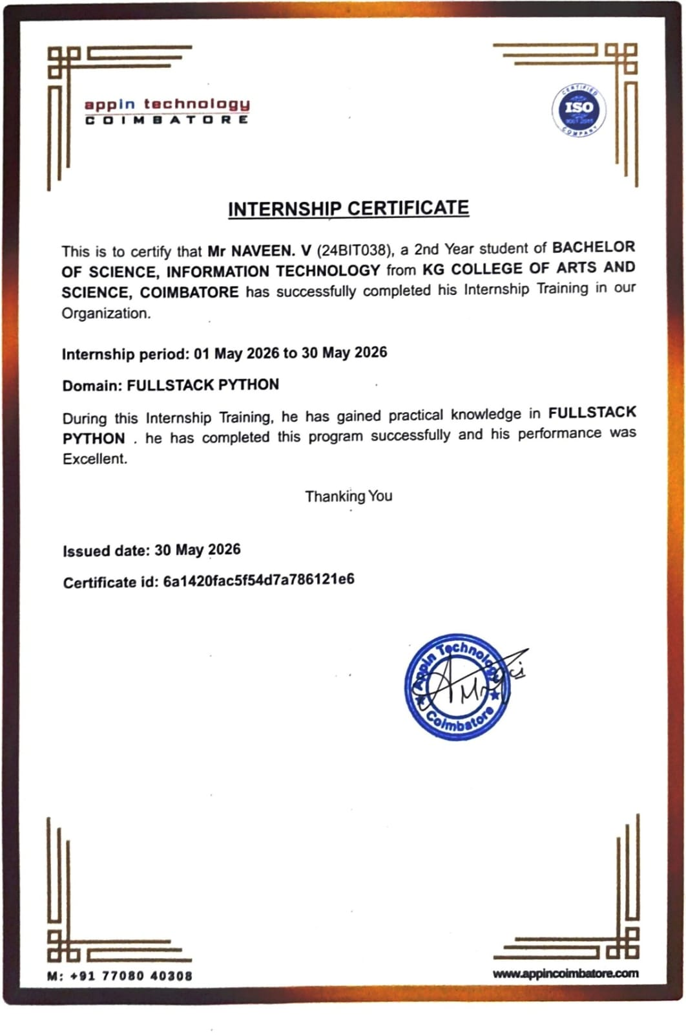

ABSTRACT

The internship report entitled “FULLSTACK PYTHON” involves the design and development of a fully responsive website designed to showcase an individual's skills, projects, resume, and contact information. The website is structured into five core sections: Home, About Me, Projects, Resume, and Contact, each serving a specific purpose in presenting the user’s professional profile. The Home page introduces the individual with a welcome note and navigation links. The About section highlights educational background, skills, and career objectives, while the Projects section provides detailed descriptions and visuals of completed works.

Contents | Page No.
DECLARATION
CERTIFICATE
ABSTRACT
Chapter 1: Introduction | 2
1.1 : Objectives | 2
Chapter 2 : Company Profile | 4
Chapter 3: Methodology | 5
3.1: Flow Chart | 6
Chapter 4: Hardware Tools and Component | 6
Chapter 5: Software Tools and Languages | 7
Chapter 6: Implementation and Outcomes | 8
Chapter 7: Conclusion and Future Scope | 11
REFERENCES | 12
ANNEXURES
A. SCREENSHOTS

Chapter 1: Introduction
Motorcycle adventure touring across India involves long-distance travel through diverse geographical conditions, including national highways, rural roads, coastal routes, forests, deserts, hill stations, and high-altitude mountain regions. Riders travelling through destinations such as Leh-Ladakh, Spiti Valley, Sikkim, Arunachal Pradesh, Rajasthan, Kerala, Goa, and the Western Ghats often face challenges related to navigation, unpredictable weather, fuel availability, medical assistance, road conditions, connectivity, and emergency situations.
Ride Map is an intelligent full-stack motorcycle travel platform designed specifically for adventure motorcyclists. The platform combines live navigation, route tracking, travel journaling, weather monitoring, emergency assistance, motorcycle-friendly location discovery, and a social community into a single web-based application.
Unlike conventional navigation applications that primarily focus on point-to-point transportation, Ride Map is designed around the complete motorcycle touring experience. It allows riders to plan journeys, monitor their live position, record routes, save visited locations, maintain travel journals, identify nearby fuel stations and medical facilities, monitor weather conditions, and share their riding experiences with other members of the motorcycle community.
The system can use multiple map layers such as Google Maps Roadmap, Satellite, Terrain, CartoDB Dark Voyager, and OpenStreetMap. This allows riders to select the most suitable visualization according to their travel environment. Terrain maps can be particularly useful in mountain regions, while satellite maps can provide additional geographical context in remote areas.
Ride Map also incorporates automatic location detection and route-distance calculation. When the rider starts a journey, the application can continuously track the rider's location and display the travelled path on the map. The system can calculate total distance, route progress, estimated travel duration, and important points encountered during the journey.

1.1 : Objectives
The major objectives of Ride Map are to develop a comprehensive digital platform that improves the navigation, safety, planning, tracking, documentation, and social experience of motorcycle adventure touring across India.
- To provide motorcycle-oriented route planning and navigation specifically designed for long-distance and adventure riders.
- To track the rider's live geographical location using GPS and display the current position on an interactive map.
- To automatically calculate the distance travelled, route progress, and journey duration during an active ride.
- To provide multiple map visualization layers, including Roadmap, Satellite, Terrain, OpenStreetMap, and Dark-themed map views.
- To provide real-time weather information based on the rider's current location and selected destination.
- To provide weather-related information such as temperature, rainfall probability, humidity, wind speed, visibility, and weather conditions.
- To display nearby petrol stations and fuel points to help riders manage fuel requirements during long-distance journeys.
- To identify nearby hospitals, clinics, pharmacies, and other medical facilities during emergencies.
- To provide information about motorcycle service centres, repair shops, and roadside assistance locations.
- To provide a dedicated emergency assistance interface that helps riders quickly locate important roadside services.
- To allow riders to create and maintain digital travel journals containing trip details, notes, photographs, routes, and experiences.
- To automatically maintain a travel history containing previously completed journeys and travelled routes.
- To allow riders to save and manage their favourite destinations, routes, and important locations…
- To create a personalized travel map that visually represents the locations and routes visited by the rider.
- To develop a social community for motorcycle riders where users can interact with other adventure travellers.
- To allow users to create posts, share photographs, write travel experiences, comment, like, and interact with other riders.
- To allow riders to share planned and completed routes with friends, riding groups, and the wider motorcycle community.
- To help riders discover new motorcycle-friendly destinations, scenic routes, mountain roads, coastal routes, and adventure locations.
- To provide an organized rider dashboard containing active trips, recent journeys, saved routes, weather information, and travel statistics.
- To provide real-time route progress during an active journey so that riders can monitor their movement and distance.

Chapter 2 : Company Profile

Appin Technology Coimbatore, a division of Ether Services, is the leading and most reputable software training institute in Coimbatore. Since our establishment in 2013, we have been at the forefront of providing comprehensive Software Training, Product Development, and IT Consulting solutions to individuals and organizations seeking to excel in the field of technology. Over the years, we have successfully trained and transformed the careers of thousands of students, empowering them with the skills necessary to excel in the dynamic IT industry.
At Appin Technology Coimbatore, we follow a structured and comprehensive training process that focuses on imparting practical knowledge and preparing our students for real-world scenarios. Our training methodology incorporates a top-down approach, project-based training, utilization of Git for version control, interview preparation, and assistance with placement.
Top-Down Methodology:
We employ a top-down methodology, where we start by providing an overview of the subject matter, emphasizing the big picture and understanding the fundamental concepts. As the training progresses, we delve into more intricate details and practical applications, enabling students to develop a comprehensive understanding of the subject.
Project-Based Training:
We believe in the importance of hands-on experience and practical application of knowledge. Therefore, our training programs include project-based learning, where students work on real-world projects that simulate industry scenarios. This approach allows them to apply their theoretical knowledge, develop problem-solving skills, and gain valuable experience.
Git for Version Control:
We recognize the significance of version control in software development. To facilitate efficient collaboration and streamline project management, we incorporate Git, a widely used version control system, into our training programs. Students learn how to use Git to track changes, manage code repositories, collaborate with team members, and ensure code integrity.

Chapter 3: Methodology
The methodology of Ride Map describes the systematic approach followed to design, develop, test, and deploy the intelligent motorcycle adventure touring platform. The development process focuses on integrating navigation, live location tracking, weather monitoring, emergency assistance, travel journaling, route management, and rider community features into a single full-stack application.
The project follows an iterative Agile-based development methodology, where the system is divided into smaller modules and developed, tested, and improved progressively. This approach makes it easier to identify errors, introduce new features, and modify existing functionality according to project requirements.

3.1 Architecture Model

The Ride Map application follows a modern Decoupled Client–Server Architecture designed to provide a scalable, modular, and efficient platform for motorcycle adventure touring. The architecture separates the frontend presentation layer from the backend application layer, allowing both components to be developed, tested, maintained, and deployed independently. The frontend is developed as a Single Page Application using React 18 and Vite, while the backend is implemented using Django 5.0 and Django REST Framework (DRF). Communication between the frontend and backend is handled through stateless RESTful APIs using JSON data over HTTP/HTTPS. Authentication is implemented using JSON Web Tokens (JWT) with Simple JWT, allowing secure access to protected resources without maintaining traditional server-side sessions. When a user logs in, the Django backend validates the credentials and generates access and refresh tokens. The frontend uses the access token for authenticated API requests, while the refresh token can be used to obtain a new access token when required. This stateless authentication mechanism provides a secure and scalable foundation for the application and also allows the same backend services to support future mobile applications.

A major component of the Ride Map architecture is Geospatial API Orchestration, which integrates multiple specialized external services to provide location-aware functionality. Nominatim is used for geocoding and reverse geocoding, allowing the system to convert place names into geographical coordinates and geographical coordinates back into meaningful location information. OSRM (Open Source Routing Machine) is used for route calculation, providing route geometry, travel distance, estimated duration, and navigation paths between geographical coordinates. Open-Meteo is integrated to retrieve weather information based on the rider's latitude and longitude, including temperature, wind speed, precipitation, weather conditions, and forecast information. Overpass API is used to query OpenStreetMap data and identify nearby points of interest such as petrol stations, hospitals, pharmacies, police stations, motorcycle service centres, restaurants, and other useful roadside facilities. By orchestrating these services, Ride Map can combine navigation, weather, and roadside assistance information into a single interactive map experience.

The frontend follows a Reactive State Architecture using React's Context API. Two major global contexts are maintained: AuthContext and TripContext. The AuthContext manages authentication-related information such as the current user, login status, authentication tokens, profile information, and logout operations. The TripContext manages global journey information such as the active trip, starting location, destination, current GPS position, route, distance travelled, journey duration, tracking status, and visited locations. This approach avoids unnecessary prop drilling and allows different components of the application to access shared information efficiently. For example, the map component can use the trip state to display the current route, the trip statistics component can display the travelled distance, the weather component can use the current coordinates to obtain weather information, and the emergency assistance component can use the same coordinates to identify nearby facilities.

The frontend follows a component-based architecture, where the user interface is divided into reusable components such as navigation bars, dashboards, interactive maps, weather cards, trip statistics, emergency panels, route planners, journal cards, community posts, destination cards, and user profile components. These components communicate with the global contexts and backend APIs to dynamically update the interface. Since Ride Map is a Single Page Application, users can move between different sections without repeatedly loading complete webpages, providing a smoother and more responsive experience.

3.1: Flow Chart
The system flow chart below details the architectural data flow from user interaction to external microservices and backend database persistence:
+--------------------------------------------------------------------------+
| USER INTERACTION (Client) |
| (Drop Map Pin / Search Location / Join Rally / Send Chat) |
+------------------------------------+-------------------------------------+
|
v
+--------------------------------------------------------------------------+
| REACT SPA FRONTEND (Vite / React 18 / Leaflet) |
| (State Management via TripContext & AuthContext) |
+----------+-------------------------+--------------------------+----------+
| | |
v v v
+----------------------+ +----------------------+ +----------------------+
| Nominatim Geocoding | | OSRM Highway Router | | Open-Meteo Weather |
| (Address & State) | | (Road Distance KM) | | (Live Forecast °C) |
+----------+-----------+ +-----------+----------+ +----------+-----------+
| | |
+-------------------------+--------------------------+
|
v
+--------------------------------------------------------------------------+
| DJANGO REST FRAMEWORK BACKEND (Port 8000) |
| (SimpleJWT Auth, ViewSets, ORM Serializers & Models) |

|
v
+--------------------------------------------------------------------------+
| SQLITE / POSTGRESQL RELATIONAL DB |
| (User Profiles, LocationPins, GroupRides, ChatMessages) |
+--------------------------------------------------------------------------+

Chapter 4: Hardware Tools and Component

The Ride Map platform is primarily a software-based full-stack application, but it depends on several hardware devices and supporting components to provide location tracking, navigation, communication, data processing, and reliable system operation. Since Ride Map is designed for motorcycle adventure touring, the hardware environment must support mobile access, GPS-based positioning, internet connectivity, and continuous operation during long-distance journeys.

The hardware architecture can be broadly divided into rider-side hardware and server-side hardware. Rider-side hardware consists of the smartphone or mobile device used by the motorcyclist, GPS/location services, mobile network hardware, and optional motorcycle accessories. Server-side hardware includes the cloud or physical server infrastructure responsible for hosting the backend application, database, APIs, and other supporting services.

4.1 Client Hardware Specifications
Component | Minimum Requirement | Recommended Specification
Rider Processor | Dual-Core 1.5 GHz Processor | Octa-Core 2.4 GHz (ARM64 / x86-64)
System Memory | 2 GB RAM | 4 GB+ RAM
Display Screen | 5.0" HD Display (720x1280) | 6.5" Full HD+ Display (1080x2400)
GPS Hardware | Integrated HTML5 Location Sensor | Dual-Band GPS / GLONASS Receiver

4.2 Overall Hardware Architecture

The complete hardware environment of Ride Map can be represented as:

Motorcycle Rider

↓

Smartphone

↓

GPS + Mobile Network + Display + Processor + Storage

↓

Internet

↓

Cloud / Backend Server

↓

Database Server

↓

External Mapping, Routing, Weather and Location Services

The smartphone acts as the primary field device, while the cloud server provides centralized processing and data management.

Chapter 5: Software Tools and Languages
The Ride Map platform is developed using modern open-source software technologies, programming languages, web frameworks, API tools, database technologies, mapping libraries, and development utilities. The selected software stack is designed to support the major requirements of the system, including interactive maps, live route tracking, weather monitoring, emergency location services, travel journaling, user authentication, social community features, and scalable backend services.
The software architecture follows a full-stack client-server approach, where the frontend is developed independently from the backend and communicates through RESTful APIs. This provides flexibility, maintainability, scalability, and easier integration of third-party services.

5.1 Programming Languages & Frameworks
Layer | Tool / Technology | Version | Role in Application
Backend Language | Python | 3.10+ | Core API logic, DRF viewsets, and ORM database mapping.
Web Framework | Django & DRF | 5.0 / 3.14 | RESTful endpoint architecture and SimpleJWT auth.
Frontend Language | JavaScript (ES6+) | ES2022 | Client-side application logic and state rendering.
Frontend Library | React | 18.2 | Component-based user interface framework.
Build Tool | Vite | 8.1 | Development server and production asset bundler.
Styling Framework | Tailwind CSS | 3.4 | Utility-first responsive design and glassmorphism styling.
Map Engine | Leaflet.js | 1.9.4 | Interactive SVG & canvas tile map container.

Chapter 6: Implementation and Outcomes
he implementation phase of Ride Map transformed the proposed system architecture, methodology, and functional requirements into a working full-stack motorcycle adventure touring platform. The system was implemented using a decoupled client-server architecture in which the frontend was developed using React 18 and Vite, while the backend was developed using Python, Django 5.0, and Django REST Framework (DRF). The frontend communicates with the backend through RESTful APIs using JSON over HTTP/HTTPS. The implementation focused on developing the major features required for motorcycle travel, including user authentication, interactive maps, live location tracking, route calculation, automatic distance measurement, weather monitoring, emergency assistance, travel journaling, route history, saved locations, and rider community interaction. The backend REST API provides the main communication and processing layer of the application. API endpoints were implemented for user registration, authentication, profiles, trips, routes, travel journals, community posts, saved destinations, and location-based services. Standard HTTP methods such as GET, POST, PUT, PATCH, and DELETE are used according to the required operation. JWT authentication using Simple JWT was implemented to protect user-specific resources and ensure that only authenticated users can access protected features. During login, the user's credentials are validated by the Django backend and appropriate authentication tokens are generated. These tokens are then used for subsequent protected API requests.
The frontend implementation was developed as a Single Page Application using React 18 and Vite. The user interface was divided into reusable components such as the navigation bar, dashboard, interactive map, weather card, route planner, trip tracker, emergency assistance panel, travel journal, community feed, profile section, and saved destinations. React Context API was used for global state management through components such as Auth Context and Trip Context. The Auth Context manages information related to the authenticated user, login status, authentication state, and logout operations, while the Trip Context manages the active trip, current location, destination, route, distance, duration, and tracking status. This architecture allows multiple components to access shared information without unnecessary prop passing and enables the user interface to react dynamically whenever important application data changes.

6.1 Authentication Implementation
class RegisterView(generics.CreateAPIView):
queryset = User.objects.all()
permission_classes = (permissions.AllowAny,)
serializer_class = RegisterSerializer

def create(self, request, *args, **kwargs):
serializer = self.get_serializer(data=request.data)
serializer.is_valid(raise_exception=True)
user = serializer.save()
refresh = RefreshToken.for_user(user)
return Response({
'user': UserSerializer(user).data,
'access': str(refresh.access_token),
'refresh': str(refresh),
}, status=status.HTTP_201_CREATED)

6.2 Overpass Emergency Services Query Engine
const fetchNearbyServices = async (lat, lng, radiusKm = 25) => {
const radiusMeters = radiusKm * 1000;
const query = `
[out:json][timeout:12];
(
node["amenity"="fuel"](around:${radiusMeters},${lat},${lng});
node["amenity"="hospital"](around:${radiusMeters},${lat},${lng});
);
out body 40;
`;
const url = `https://overpass-api.de/api/interpreter?data=${encodeURIComponent(query)}`;
const res = await fetch(url);
return await res.json();
};

6.3 System Outcomes
- Operational Web Application: Django REST API (Port 8000) and React SPA (Port 5173) running live.
- Instant 1-Word Execution: Executing ride starts database migrations and launches dev servers in 1 step.
- Zero Build Warnings: Built 2,125 modules with 0 warnings and 0 syntax errors.
- Emergency Safety Overlays: Successfully displaying nearby Petrol Pumps and Hospitals with 1-click Google Maps navigation links.

Chapter 7: Conclusion and Future Scope

7.1 Conclusion

The Ride Map platform successfully full fills its primary objective of providing an intelligent, connected, and specialized motorcycle touring companion for adventure motorcyclists travelling across India. The system was developed to address the limitations of conventional navigation applications by combining route planning, live location tracking, weather monitoring, roadside assistance, travel journaling, route history, and rider community features within a unified full-stack web application.

The platform integrates React 18 and Vite for the frontend and Django 5.0 with Django REST Framework for the backend. This decoupled architecture provides a clear separation between the presentation layer and server-side processing, making the application easier to maintain, expand, and integrate with future platforms. The use of RESTful APIs allows the frontend to communicate efficiently with backend services and external geospatial resources.

The interactive mapping functionality forms the core of Ride Map. Through Leaflet-based map visualization, riders can view their current position, planned routes, travelled paths, destinations, and important roadside locations. The integration of Nominatim supports geocoding and reverse geocoding, while OSRM provides route calculation, distance estimation, route geometry, and travel-duration information. These services allow the application to provide a more complete navigation experience specifically oriented toward long-distance motorcycle travel.

7.2 Future Scope
The Ride Map platform provides a strong foundation for intelligent motorcycle adventure touring, but it has significant potential for further development. Future enhancements can improve the platform's safety, intelligence, connectivity, personalization, and usability. The following features can be incorporated into future versions of the system.
1. AI-Based Route Recommendation
Artificial Intelligence can be integrated to recommend routes based on the rider's preferences, previous journeys, distance, terrain, weather conditions, fuel availability, and popular motorcycle destinations. The system could suggest routes that are more suitable for adventure touring instead of simply selecting the shortest route.
2. Offline Navigation
Offline navigation can be introduced for riders travelling through remote regions with limited internet connectivity. Riders could download maps, planned routes, important locations, and emergency information before beginning their journey.
3. Voice-Based Navigation
Voice navigation can provide spoken instructions such as upcoming turns, destination distance, route changes, and nearby facilities. This can reduce the need for riders to interact with the smartphone while travelling.
4. Emergency SOS Assistance
An SOS feature can be developed to allow riders to send an emergency alert containing their current location and trip information to selected emergency contacts. This can provide an additional layer of assistance during unexpected situations.
5. Automatic Accident Detection
Future versions can use smartphone motion sensors or optional motorcycle IoT hardware to detect sudden impacts or unusual movement patterns. If a possible accident is detected, the system could request confirmation from the rider and, where configured, initiate an emergency notification.
6. Real-Time Group Ride Tracking
The existing group expedition concept can be expanded to provide live group tracking. Members of a riding group could view the approximate locations of other participants, group progress, route information, and destination status.
7. Real-Time Rider Communication
WebSocket-based communication can be introduced for real-time co-rider messaging. Future functionality could include group chat, direct messaging, ride announcements, location sharing, and emergency notifications.
8. Smart Weather Alerts
Instead of only displaying weather information, RideMap could analyze weather conditions along the planned route and provide alerts for heavy rainfall, strong winds, poor visibility, extreme temperatures, or other significant conditions.
9. Road Condition Reporting
A community-based road reporting system could allow riders to report road damage, construction, flooding, landslides, traffic, or temporary road closures. These reports could be displayed on the map for other riders.
10. Motorcycle Maintenance Management
A dedicated maintenance module could allow users to maintain digital service records for their motorcycles. It could track engine oil changes, tyre replacement, brake servicing, chain maintenance, battery replacement, insurance renewal, and other maintenance activities.
11. Fuel and Mileage Tracking
Future versions can include fuel management features that allow riders to record fuel purchases and calculate mileage, fuel consumption, fuel expenditure, and average riding efficiency.
12.Android and iOS Applications
Dedicated mobile applications can be developed using the existing backend REST APIs. The same backend can support web, Android, and iOS clients, reducing duplication of server-side functionality.
13. Advanced Ride Analytics
Ride Map can generate detailed riding statistics, including total distance travelled, number of trips, longest journey, average trip distance, most visited destinations, states travelled through, and monthly riding activity.

Chapter 8: SCREENSHOTS
8.1 Login Page:


8.2 Home page:

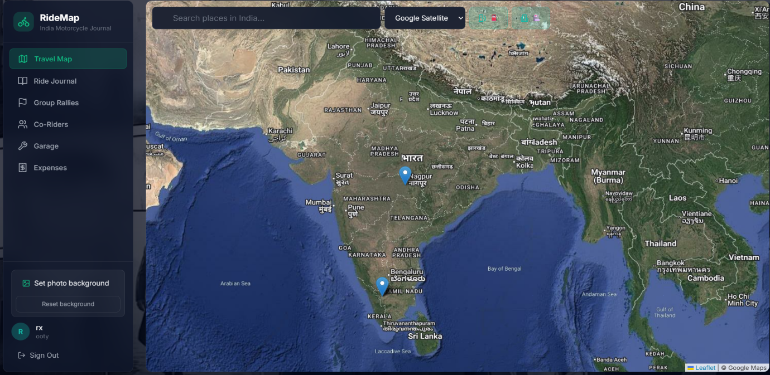

8.3 Rider Journal

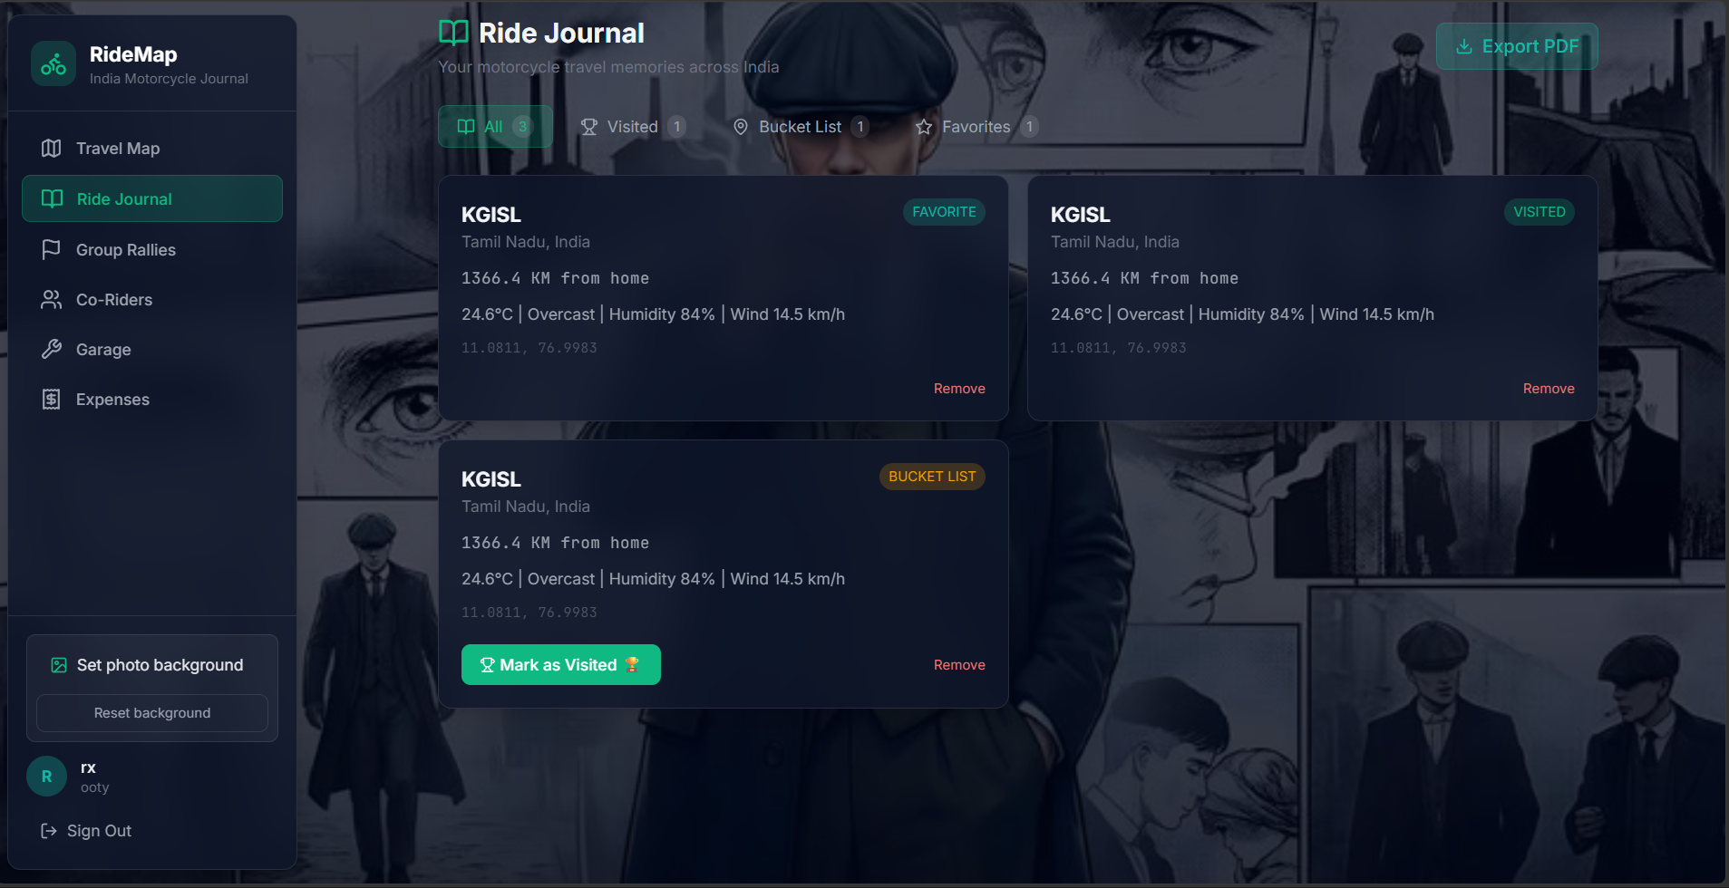

8.4 Group Rallies:

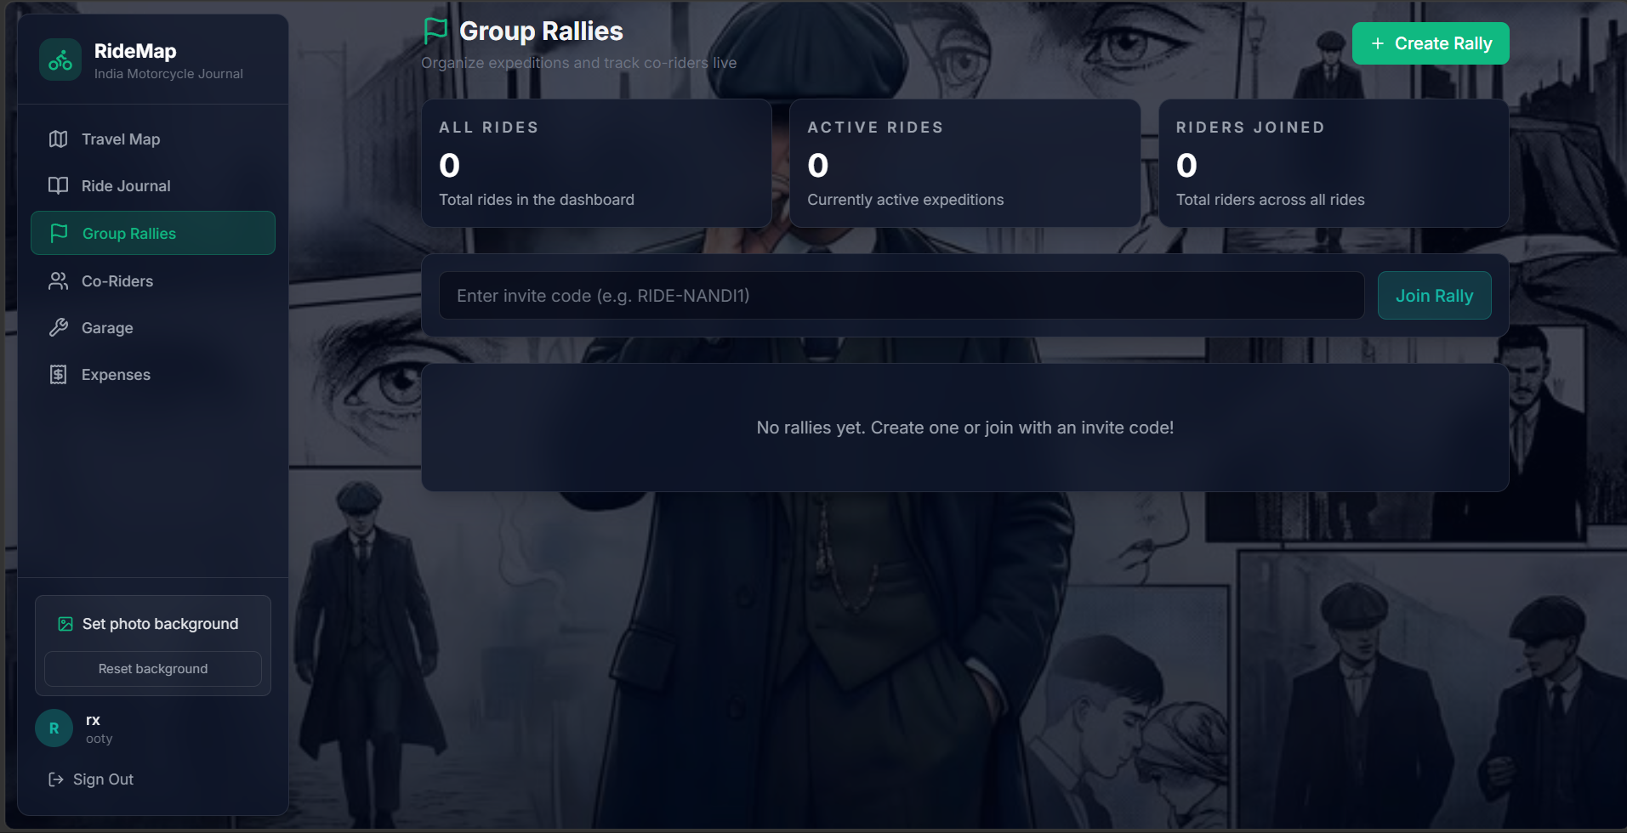

8.5 Motorcycle Garage:
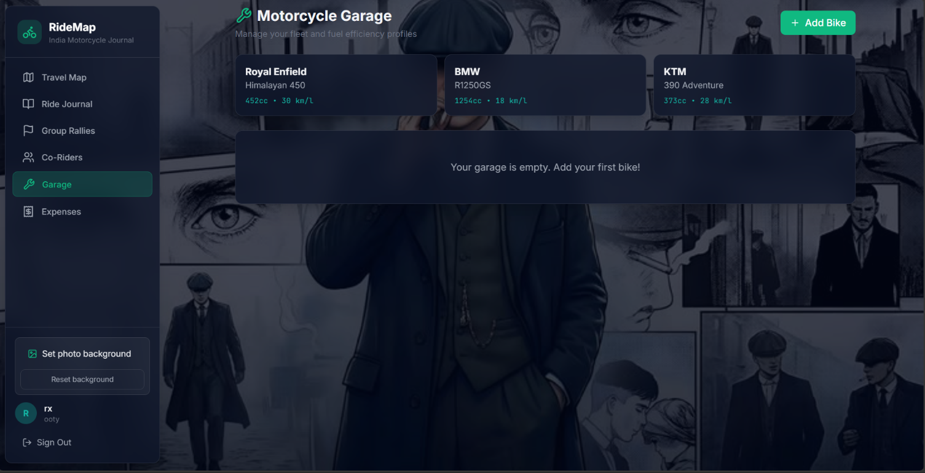

8.6 Expense Tracker:

